


Module Code & Module Title
CU6051NI Artificial Intelligence

25% Individual Coursework
Submission: Milestone 1
Academic Semester: Autumn Semester 2025
Credit: 15 credit semester long module

Student Name: Anurodh Prasain
London Met ID: 23047512
College ID: np01cp4a230012
Assignment Due Date: 17/12/2025.
Assignment Submission Date: 17/12/2025
Submitted To: Mr. Alish KC

GitHub Link

I confirm that I understand my coursework needs to be submitted online via MST Classroom under the relevant module page before the deadline for my assignment to be accepted and marked. I am fully aware that late submissions will be treated as non-submission and a mark of zero will be awarded.

Table of Contents
1. Introduction 1
1.1. Problem Domain: Breast Cancer Diagnosis 2
1.2. Models Selected for the Study 3
1.3. Objective of this project 3
2. Background 4
2.1. Analysis of the Existing Scenario 4
2.1. Research work done on the chosen topic/problem domain 5
2.1.1. Research Paper 1: Machine Learning Algorithms to predict and diagnose breast cancer 5
2.1.2. Research Paper 2: Breast Cancer Prediction and Diagnosis with the help of machine and modern deep learning models 7
2.1.3. Research Paper 3: AI-based predictive modeling of breast cancer classification and explainable AI (Taminul Islam, 2024). 11
2.2.4. Research Paper 4: Diagnostic Features-based Breast Cancer Diagnosis with the help of Machine Learning (Arslan Khalid, 2023). 14
2.2.5. Research Paper 5: Comparative Study of Supervised Learning Methodology of Breast Cancer Prediction (Mubarak Taiwo Mustapha, 2022). 16
2.2. Review and analysis of existing work in the problem domain 18
3. Proposed Solution 20
3.1. Proposed approach to solve the problem 20
3.2. Explanation of the AI algorithms used 20
3.2.1. Logistic Regression 20
3.2.2. Decision Tree Algorithm 21
3.2.3. K-Nearest Neighbours (KNN) 22
3.3. Pseudocode of the solution 23
3.3.1. Pseudocode for Logistic Regression 23
3.3.2. Pseudocode for Decision Tree Algorithm 24
3.3.3 Pseudocode for K-Nearest Neighbours Algorithm 24
3.4. Flow Chart 25
3.4.1. Flow Chart for Logistic Regression 25
3.4.2. Flow Chart for Decision Tree 28
3.4.3. Flow Chart for K-Nearest Neighbours 32
4. Conclusion 36
4.1. Analysis of the work done 36
4.2. How the solution addresses real world problems 36
4.3. Future Work 37
References 38

Table of Figures
Figure 1: AI Index technical performance benchmarks vs human performance (Stanford University, 2025). 2
Figure 2: Process Flow Diagram of Research Paper 1 (Mohammed Amine Naji, 2021). 5
Figure 3: Wisconsin Breast Cancer Diagnostic Dataset (Mohammed Amine Naji, 2021). 6
Figure 4: Comparative graph of different classifiers (Mohammed Amine Naji, 2021). 7
Figure 5: Flow Diagram of Research Paper 2. 8
Figure 6: ROC Analysis of Malignant Tumour (Seeta Devi, 2024). 8
Figure 7: ROC Analysis of benign Tumour (Seeta Devi, 2024). 10
Figure 8: Correlation Matrix between Each Feature (Seeta Devi, 2024). 10
Figure 9: Ratio of malignant and benign data (Taminul Islam, 2024). 11
Figure 10: Visualizing the workflow of the proposed mode (Taminul Islam, 2024). 12
Figure 11: Hyperparameter tuning with performance metrics (Taminul Islam, 2024). 12
Figure 12: Dependence Plot for XGBoost Model (Taminul Islam, 2024). 13
Figure 13: Proposed Methodology (Arslan Khalid, 2023). 14
Figure 14: Breast cancer diagnosis graph (Arslan Khalid, 2023). 15
Figure 15: Classifiers accuracy result (Arslan Khalid, 2023). 15
Figure 16: Confusion Matrix. 17
Figure 17: Decision matrix of alternatives for the BIRADS dataset. 17
Figure 18: Logistic Regression Flow Chart. 27
Figure 19: Decision Tree Flow Chart. 31
Figure 20: KNN Flow Chart. 35

Table of Tables
Table 1: Accuracy percentage for breast cancer diagnostic dataset (Mohammed Amine Naji, 2021). 6
Table 2: Prediction Output (Seeta Devi, 2024). 9

1. Introduction
Artificial Intelligence (AI) is a disruptive technology providing computers with capabilities to learn, reason, understand language and analyze data, in a manner like humans. It is based on various disciplines such as computer science, linguistics and neuroscience. In essence, AI tries to simulate human cognitive functions, such as the ability to comprehend the world and derive some ideas and obtain valuable insights out of information. One such usage is Optical Character Recognition (OCR), which transforms unstructured images and documents into structured and usable data. In general, AI can be used as an effective means of bringing positive transformation to society (Google Cloud, 2025).
Machine learning is the subdivision of artificial intelligence (AI) that deals with the algorithms that can learn the trends of the training data and, when properly trained, become able to effectively infer the new data. This pattern recognition capability allows machine learning models to take decisions or predictions without clear-cut or hard-coded guidance (Bergmann, 2025).
Any machine learning approach can be classified into one of three different learning paradigms:
- Supervised learning: It is a method that will train a model to give a correct prediction of the output that should be given based on an input. It is applicable to problems where some accuracy with respect to some external ground truth is required, e.g. classification or regression (Bergmann, 2025).
- Unsupervised learning: It uses a model to identify inherent patterns, dependencies and correlations in the data. Unsupervised learning tasks do not have any external ground truth with which the results of a particular learning task can be compared, unlike supervised learning (Bergmann, 2025).
- Reinforcement learning (RL): It is a process that trains a model to analyze its world and make a decision that will result in the highest reward. The situations in RL do not imply the presence of a single ground truth, but they imply the presence of good and bad (or neutral) actions (Bergmann, 2025).
In supervised learning, tasks can be divided into classification and regression depending on the nature of the target variable. Since the selected dataset has the target variable Diagnosis with two categories (Malignant and Benign), this problem is a binary classification task, making classification algorithms suitable for modelling.

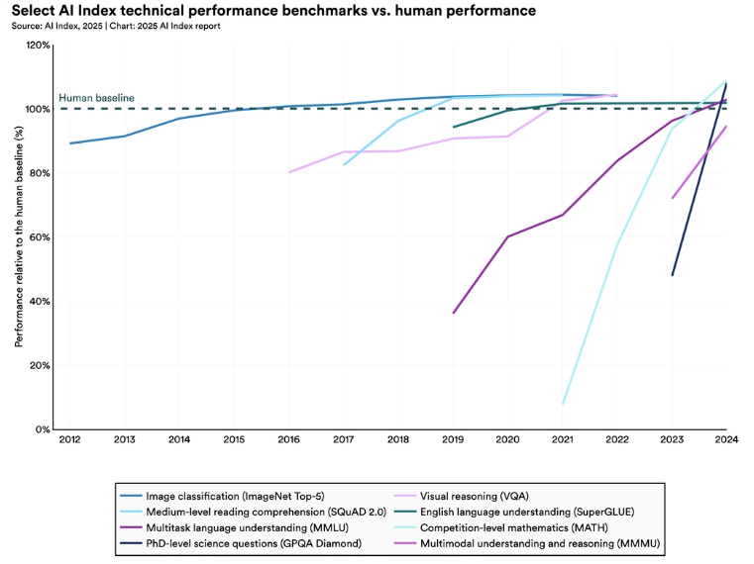
Figure 1: AI Index technical performance benchmarks vs human performance (Stanford University, 2025).

Problem Domain: Breast Cancer Diagnosis
Breast cancer is a malignant tumour that occurs due to uncontrolled proliferation of breast cells, and it is one of the major causes of death because of cancer in women in the world. Early diagnosis and treatment are great positives in terms of the survival rates and the choice of the treatment, which lowers the mortality and healthcare costs. Machine learning has become a significant instrument to aid in clinical decision-making by training diagnostic patterns based on the patient information and medical images. Various researchers have shown the success of such supervised learning frameworks as logistic regression, K-Nearest Neighbours (KNN), decision tree classifiers and others to classify breast tumours based on such features as cell size, texture and morphology (Aryan Sai Boddu, 2025).

Models Selected for the Study
To address the binary classification problem in this dataset the following supervised learning algorithms are applied in the coursework:
- Logistic Regression: a statistical classification technique that is common in binary outcomes and offers probabilities and interpretable coefficients that aid in the understanding of the effects of features.
- K-Nearest Neighbours (KNN): an instance-based learning algorithm which classifies instances based on the classification of nearest instances in feature space, showing how similarity measurements can be employed in classification problems.
- Decision Tree Classifier: is a supervised learning model based on rules, which divides a dataset based on characteristic thresholds to create rational decision pathways; it is also user-friendly and visualizable.
Based on these models, a variety of classification strategies, among them probabilistic, instance-based and tree-structured approaches, was selected, which allowed to compare the performance and interpretability of the task of tumour classification in a comprehensive manner (Yoo-Shin Park, 2025).

Objective of this project
This coursework has the following objectives:
- The fundamentals of the supervised machine learning classification.
- The use of logistic regression, KNN, and decision tree classifiers on the selected data.
- The measure and comparison of performance of these algorithms based on relevant measures.
- Determining which model can best be used to predict breast cancer diagnosis.
- Proving the practical relevance of supervised learning to medical decision support.

2. Background

2.1. Analysis of the Existing Scenario
In 2021, the World Health Organization established the Global Breast Cancer Initiative (GBCI), to bring together stakeholders from around the world and across sectors with the shared goal of reducing global breast cancer mortality by 2.5% per year, thereby averting 2.5 million breast cancer deaths globally by 2040. The three pillars of action are: health promotion for early detection; timely diagnosis; and comprehensive breast cancer management. It is one of the most common causes of death among women all over the world, which means the critical need to detect it as early as possible and be sure of the diagnosis (WHO, 2025).
The classical methods of diagnosing like biopsy, mammography, and histopathological analysis are useful but mostly time-consuming, resource-consuming, and prone to variability in human interpretation (National Cancer Institute, 2025). Using numerical features retrieved from fine needle aspirate (FNA) images, supervised machine learning classification has demonstrated great promise in differentiating between benign and malignant tumours. Because of their structured feature space and clinical significance, publicly accessible datasets like the Breast Cancer Wisconsin Diagnostic (WBCD) dataset have emerged as a standard for assessing classification algorithms (R. Fang, 2025).

2.1. Research work done on the chosen topic/problem domain
In this section, we will examine the current research literature associated with the breast cancer prediction with the help of the supervised machine learning algorithms, i.e., classification-based ones.

2.1.1. Research Paper 1: Machine Learning Algorithms to predict and diagnose breast cancer

Problem Statement
This paper will assess and compare various supervised machine learning algorithms to determine the best classifier of breast cancer prediction and diagnosis using the Wisconsin Diagnostic dataset.
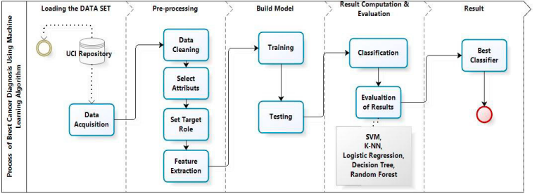
Figure 2: Process Flow Diagram of Research Paper 1 (Mohammed Amine Naji, 2021).

Algorithms Used
- Support Vector Machine (SVM)
- Random Forest
- Logistic Regression
- Decision Tree
- K-Nearest Neighbors (KNN)

Dataset Description
The authors applied the Breast Cancer Wisconsin Diagnostic dataset which consists of 569 cases where the numerical features were created because of digitization of breast cell nuclei. The target variable is used to classify tumors as benign and malignant (Mohammed Amine Naji, 2021).
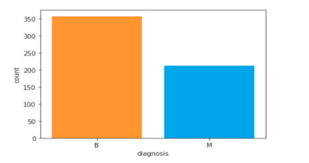
Figure 3: Wisconsin Breast Cancer Diagnostic Dataset (Mohammed Amine Naji, 2021).

Key Findings
- SVM had the best test accuracy of 97.2.
- There was also strong performance by Logistic Regression, Decision Tree and KNN.
- Evaluation metrics were given in form of confusion matrix, accuracy, precision, sensitivity, F1-score, and ROC-AUC (Mohammed Amine Naji, 2021).

Algorithm | Training Accuracy (%) | Testing Accuracy (%)
SVM | 98.4 | 97.2
Random Forest | 99.8 | 96.5
Logistic Regression | 95.5 | 95.8
Decision Tree | 98.8 | 95.1
K-NN | 94.6 | 93.7
Table 1: Accuracy percentage for breast cancer diagnostic dataset (Mohammed Amine Naji, 2021).
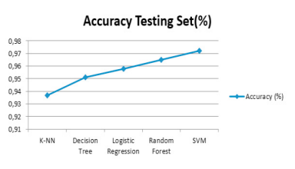
Figure 4: Comparative graph of different classifiers (Mohammed Amine Naji, 2021).

2.1.2. Research Paper 2: Breast Cancer Prediction and Diagnosis with the help of machine and modern deep learning models

Problem Statement
This paper will examine the performance of classical machine learning and state-of-the-art deep learning to detect breast cancer using the Wisconsin Diagnostic data.
Algorithms Used
- k-Nearest Neighbors (kNN)
- Naive Bayes
- Decision Tree
- Support Vector Machine
- Gradient Boosting
- CN2 Rule Inducer
- Neural Networks (Neural Decision Forest, MLP)

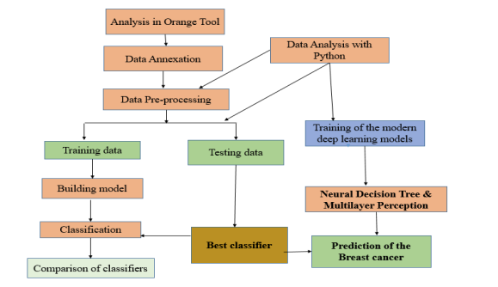
Figure 5: Flow Diagram of Research Paper 2.

Dataset Description
The data is comprised of 569 records of patients, and 30 numerical variables describe geometric and textural characteristics of cell nuclei. The data can be found in the UCI Machine Learning Repository (Seeta Devi, 2024).
Key Findings
- Gradient Boosting and CN2 Rule Inducer had perfect scores in classification.
- The performance of traditional ML models (Decision tree, Naive Bayes, kNN) was competitive.
- Deep learning models had a high ROC-AUC (0.9959) (Seeta Devi, 2024).

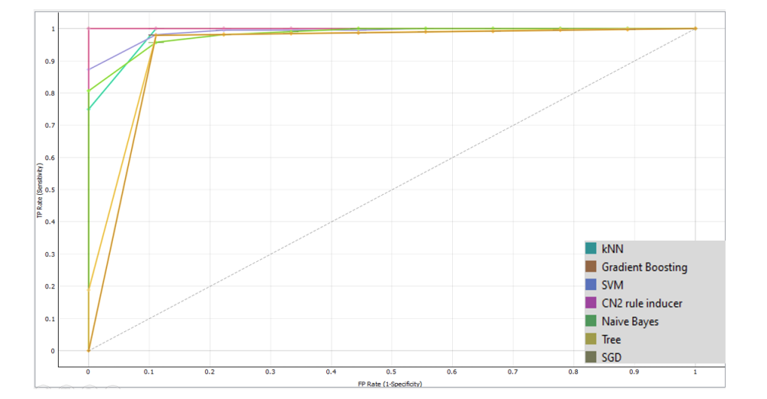
Figure 6: ROC Analysis of Malignant Tumour (Seeta Devi, 2024).

Metric | Neural Decision Forest | Multilayer Perceptron
AUC-ROC | 0.9667 | 0.9959
Accuracy (%) | 95.61 | 96.49
Precision (%) | 100 | 96.57
Recall (%) | 89.36 | 96.49
F1-Score (%) | 94.38 | 96.50
Table 2: Prediction Output (Seeta Devi, 2024).
This implies higher overall prediction performance.
Accuracy = True Positive/True Negative + True Negative + Negative)

Precision
Precision denotes the percentage of occurrences the model is correct on all the positive instances only; it denotes as positive. The model is denoted by a high precision produces less false positive errors.
- Formula: Precision = TP / (TP + FP)
F1 Score
It portrays their harmonious average, striking a harmonious tradeoff between accuracy and recall. A score of 1 indicates a tradeoff between the two, and a value<|human|>represents a balance between the two, and a value of 0 happens when one of the two attains high elevation.
- FormulaF1 Score = 2 x Precision Recall) / (Precision + Recall))
AUC-ROC
Area Under the Receiver Operating Characteristic. Curve (AUC-ROC) is the ability of a model to differentiate positive and negative events throughout several levels of threshold. A higher AUC-ROC value represents improved performance of the model regarding classification.

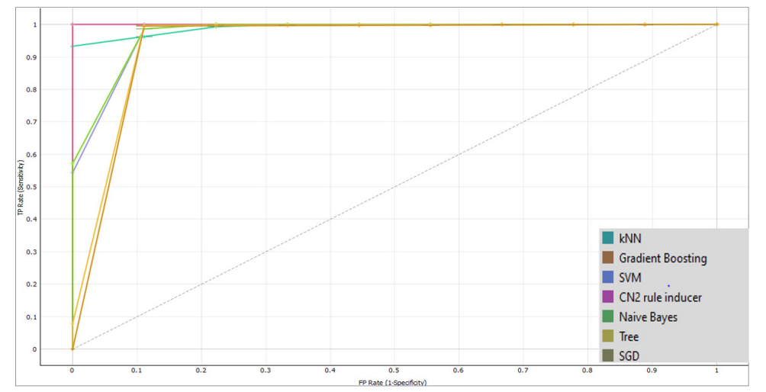
Figure 7: ROC Analysis of benign Tumour (Seeta Devi, 2024).
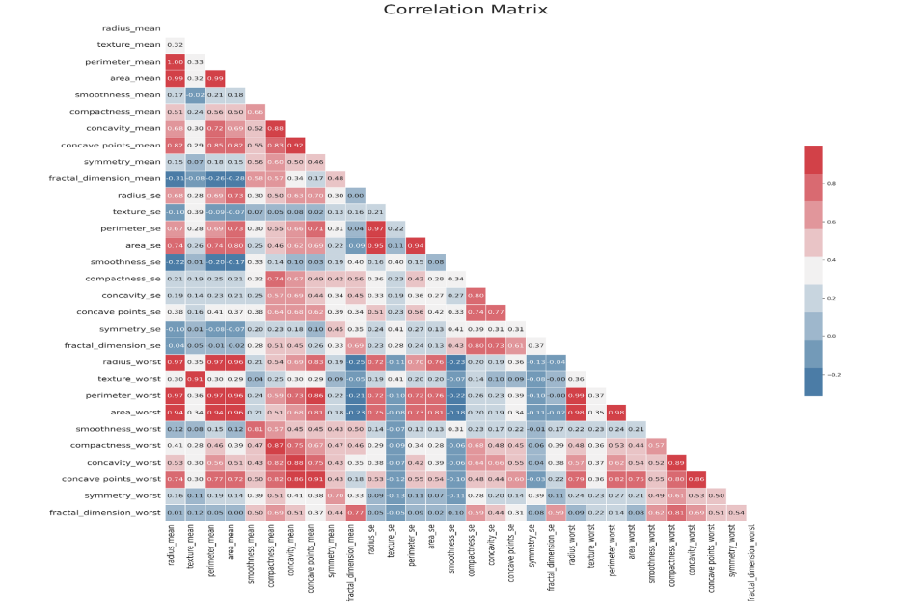
Figure 8: Correlation Matrix between Each Feature (Seeta Devi, 2024).

2.1.3. Research Paper 3: AI-based predictive modeling of breast cancer classification and explainable AI (Taminul Islam, 2024).

Problem Statement
The proposed paper deals with the issue of proper classification of breast cancer tumors using machine learning methods with explainable AI (XAI). In contrast to the old methods, it has model interpretability (with SHAP) and classification to provide clinical indications of feature contributions.
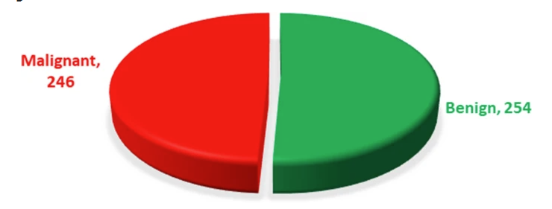
Figure 9: Ratio of malignant and benign data (Taminul Islam, 2024).
Dataset & Methodology
- The major clinical data of 500 patients was gathered in Dhaka Medical College Hospital.
- The dataset contains some structured diagnostic measures like the Wisconsin Diagnostic dataset but in a locally collected clinical setting.
- Various machine learning models were tested: Decision Tree, Random Forest, Logistic Regression, Naive Bayes and XGBoost.
- SHAP analysis has been applied to give explainable AI insights of the importance of features to classification decisions.

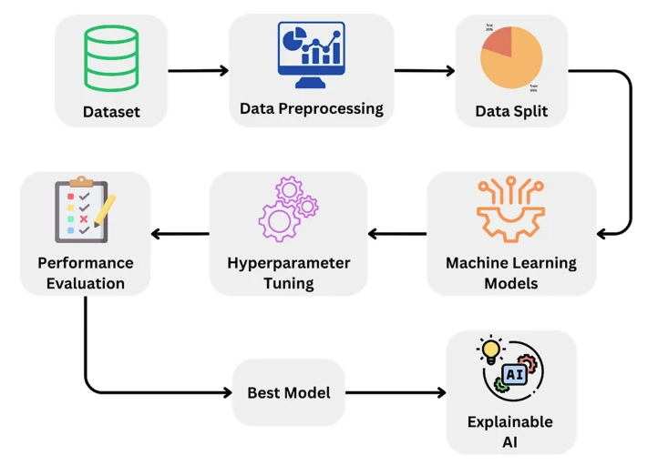
Figure 10: Visualizing the workflow of the proposed mode (Taminul Islam, 2024).

Key Findings
- The results of Logistic Regression, Decisional Tree, and Random Forest were not the best, whereas XGBoost turned out to be the most accurate (97%).
- Explainable AI algorithms such as SHAP offered pictorial information about the effect of features (such as tumor texture and area) on predictions.
- This article underscores the importance of performance and interpretability in medical artificial intelligence.
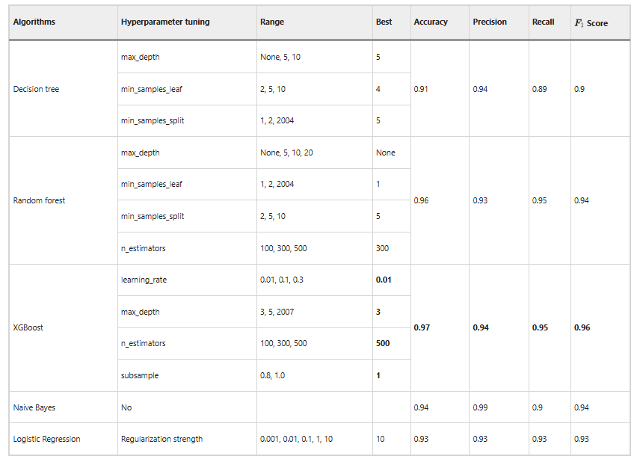
Figure 11: Hyperparameter tuning with performance metrics (Taminul Islam, 2024).

With an effective precision of 0.97 and high precision, recall, and F1 scores, the XGBoost algorithm performed better than the others in terms of performance metrics. With a balanced accuracy trade-off and an accuracy of 0.96, the random forest algorithm also demonstrated strong performance. With a balanced F1 score of 0.90 and an accuracy of 0.91, the decision tree algorithm produced good results. With F1 scores of 0.94 and 0.93, respectively, Naive Bayes and logistic regression demonstrate competitive performance. All things considered, hyper-parameter tuning is crucial to enhancing the model's performance, and the algorithm selection had a big impact on the outcome; XGBoost and Random Forest stand out as high-performance models.

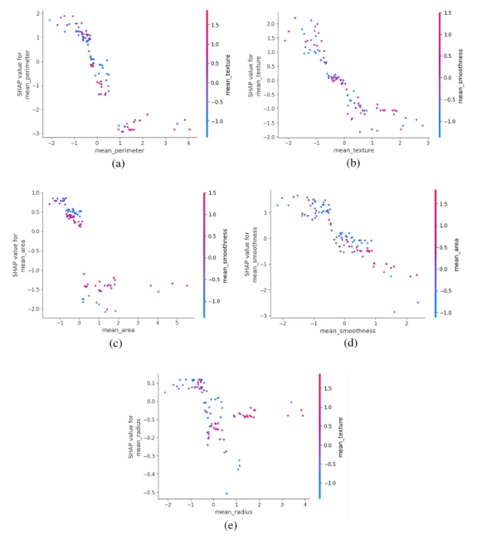
Figure 12: Dependence Plot for XGBoost Model (Taminul Islam, 2024).

2.2.4. Research Paper 4: Diagnostic Features-based Breast Cancer Diagnosis with the help of Machine Learning (Arslan Khalid, 2023).

Problem Statement
The paper under consideration explores the ability of various supervised machine learning classifiers to detect breast cancer at its early stages based on the structured diagnostic features of the tumor cell nuclei. The central question is to identify the best algorithms in clinical decision support system that offer an optimal balance between accuracy, robustness and interpretability.
Algorithms Used
- Logistic Regression
- K-Nearest Neighbors (KNN)
- Decision Tree
- Random Forest
- Support Vector Machine (SVM)
These algorithms are measured by classification tasks like finding accuracy, precision, recall, F1-score, and ROC-AUC.

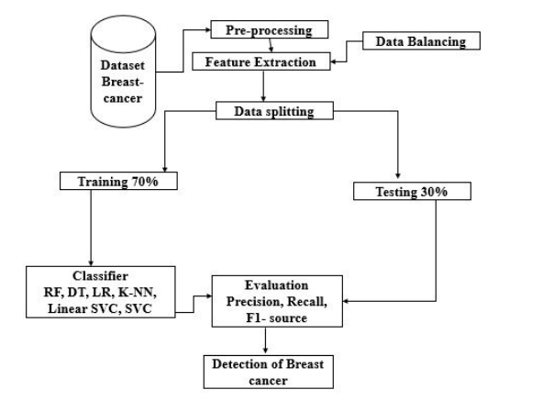
Figure 13: Proposed Methodology (Arslan Khalid, 2023).

Dataset Description
- The dataset employed in the study is that of Breast Cancer Wisconsin Diagnostic (WBCD).
- It is a dataset of 569 samples containing 30 numerical variables that were derived because of fine needle aspirate (FNA) images.
- The target variable will classify tumours as either being malignant or benign which is directly corresponding to the data in this course work (Arslan Khalid, 2023).
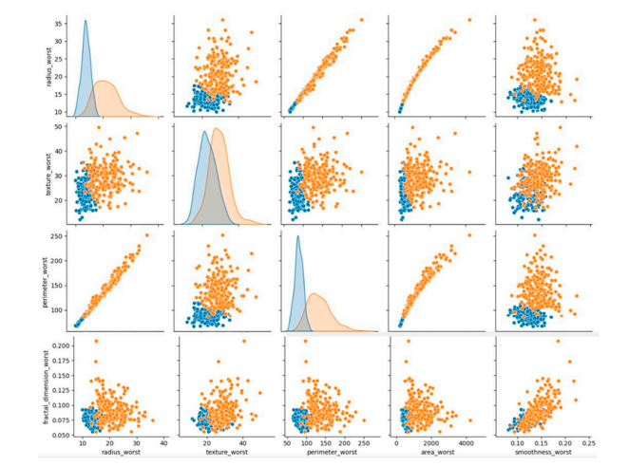
Figure 14: Breast cancer diagnosis graph (Arslan Khalid, 2023).

Key Findings
- The results of Logistic Regression and Random Forest were very high in terms of classification (>95%).
- After normalizing features, KNN showed a good performance.
- Decision tree models gave interpretable decision rules but were highly likely to overfitting.
- The paper highlights the significance of distance-based classifiers preprocessing and feature scaling.
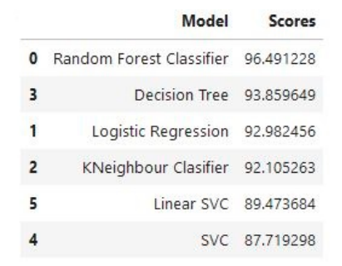
Figure 15: Classifiers accuracy result (Arslan Khalid, 2023).

2.2.5. Research Paper 5: Comparative Study of Supervised Learning Methodology of Breast Cancer Prediction (Mubarak Taiwo Mustapha, 2022).

Problem Statement
The proposed research is aimed at a comparative evaluation of conventional supervised learning algorithms to determine the most efficient model to be used to predict breast cancer. This research will compare the performance of classifiers when using medical diagnostic information at interpretability and cost effectiveness.
Algorithms Used
- Naive Bayes
- Logistic Regression
- Decision Tree
- K-Nearest Neighbors
- Support Vector Machine
The article highlights the applicability of classical ML algorithms to real-world medical datasets of limited samples.
Dataset Description
- Works with the Wisconsin Diagnostic Breast Cancer data.
- Has 30 non-laboratory diagnostic attributes.
- Balanced binary problem (benign vs malignant).
This data structure is identical to the data set that was chosen in this coursework, which confirms the significance of the study.
Key Findings
- The results of Logistic Regression always gave stable and understandable results.
- KNN was sensitive to feature scaling and values of k.
- Decision Tree models were used to point out the influential diagnostic features, but they needed pruning.
- Naive Bayes was also efficacious though it assumed the independence of features, which had a minor impact on accuracy.

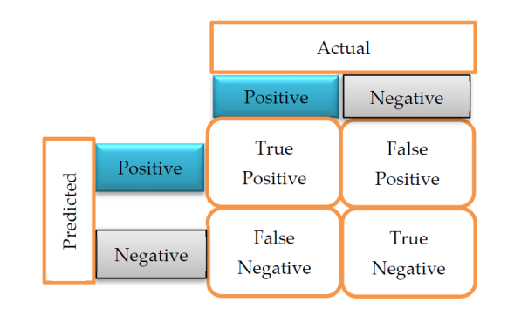
Figure 16: Confusion Matrix.

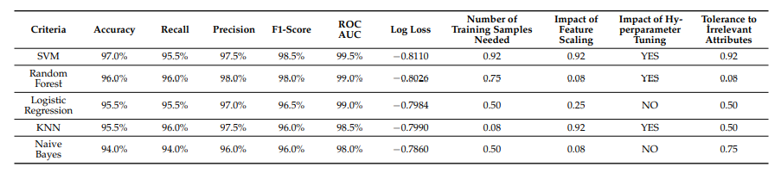
Figure 17: Decision matrix of alternatives for the BIRADS dataset.

2.2. Review and analysis of existing work in the problem domain
The diagnosis of breast cancer has been an extensively investigated supervised machine learning problem because the existence of properly organized medical data and the urgent necessity to diagnose breast cancer at the earliest possible stage support this diagnosis. It has been shown that machine learning models are capable of successfully classifying breast tumours as malignant or benign based on numerical features that have been obtained through the analysis of fine needle aspirate (FNA) images.
Some available literature has effectively used the Logistic Regression, Decision Tree and K-Nearest Neighbours (KNN) algorithms on the Breast Cancer Wisconsin Diagnostic dataset. Logistic Regression is popular due to its statistical basis and ability to be easily interpreted and thus it can be used in medical decision support systems. The results of a research study suggest that the accuracy of logistic regression is high when it is applied to well-normalized data and the output of probabilities is used to assist clinicians to understand prediction confidence.
Decision Tree techniques have also been experimented widely. The models develop rule-based frameworks that replicate the way humans make decisions enabling medical practitioners to trace the way a classification decision is made. It has been established that Decision Trees are effective in the determination of significant tumour features including concavity, radius, and perimeter. Nevertheless, other issues documented in the literature include overfitting that can be addressed by pruning methods and limiting the depth of the trees.
The use of K-Nearest Neighbours (KNN) as an instance-based learning algorithm has been used in predicting breast cancer. Previous works show that KNN is highly accurate with distance measures that are used with an appropriate feature scaling. The biggest limitation that was found in literature is the high cost of computation when dealing with large datasets, yet in the case of moderate sized datasets in medicine, KNN is also a good and dependable classifier.
Altogether, the analysis of the available literature proves that machine learning algorithms under supervision are quite appropriate to diagnose breast cancer. The previous studies confirm the efficiency of these algorithms and indicate the significance of the data preprocessing, feature normalization, and performance assessment. The proposed project is based on the existing research findings through a comparison of various methods of classification and an effective diagnostic model.

3. Proposed Solution

3.1. Proposed approach to solve the problem
The solution proposed is to create a smart breast cancer diagnosis system through supervised machine learning algorithms. The system is parameterized to categorize the tumours according to the number of malignant or benign features of the medical imaging data.

The methodology takes a systematic flow starting with the data acquisition and preprocessing. In the first step, the dataset is cleaned by eliminating the useless attributes like the unique identifiers and by treating the missing values, in case they are there. The feature normalization is used to make all the numerical features equal to the learning process, especially when one is using a distance-based algorithm like KNN.
The data is pre-processed and then split into a training and a testing sample. Several classification methods are then trained on the same data, these include Logistic Regression, Decision Tree and K-Nearest Neighbours (KNN). This multi-model can be used to compare the performance and provides the robustness of the predictions.
Accuracy, precision, recall, and F1-score are the performance metrics applied to evaluate the trained models. The most effective model can then be employed to help healthcare professionals in the early diagnosis of breast cancer using the decision-support tool. The solution saves time in diagnoses, lowers the human error, and promotes clinical decisions based on data.

3.2. Explanation of the AI algorithms used
This project uses supervised learning classification algorithms due to the availability of labelled data.

3.2.1. Logistic Regression
Logistic regression is a supervised machine learning algorithm in data science. It is a type of classification algorithm that predicts a discrete or categorical outcome. For example, we can use a classification model to determine whether a loan is approved or not based on predictors such as savings amount, income and credit score (Lee, 2025).
Logistic regression is frequently used in medical diagnosis because it is easy to interpret and yields coefficients that show how each feature affects the prediction result.
Mathematical Formulation
Let a single tumor sample be represented as:
X = (Xradius_means, Xtexture_mean, …, Xfractal_dimension_worst)

Let the corresponding weights be:
W = (Xradius_mean, Xtexture_mean, …, Xfractal_dimension_worst)

The linear model is:
Z = (Wradius_mean * Xradius_mean) + (Wtexture_mean * Xtexture_mean) + … + (Wfractal_dimension_worst * Xfractal_dimension_worst) + b

The sigmoid function converts this into a probability:
P _{(Malignant | X)} = 1 / (1 + e^{-z})

Classification rule:
y ^​ = Malignant (M), P >= 0.5 or Benign (B), P < 0.5

Relevance to the Dataset
- Diagnostic features describe geometric and textural similarity.
- KNN captures local similarity patterns among tumors.
- Particularly sensitive to features such as radius_mean, perimeter_worst, and area_worst.

3.2.2. Decision Tree Algorithm
A decision tree is a non-parametric supervised learning algorithm, which is utilized for both classification and regression tasks. It has a hierarchical, tree structure, which consists of a root node, branches, internal nodes and leaf nodes (Kavlakoglu, 2025).
Mathematical Formulation
Given two tumour samples x and y:
x = (xradius_mean​, xtexture_mean​, …, xfractal_dimension_worst​)
y = (yradius_mean​, ytexture_mean​, …, yfractal_dimension_worst​)

The Euclidean distance is calculated as:
d (x, y) = √ [(xradius_mean​ − yradius_mean​)² + (xtexture_mean​ − ytexture_mean)² + ⋯ + (xfractal_dimension_worst​ − yfractal_dimension_worst​)²]
The predicted class is determined by majority voting:
$$\overset{^}{y}=arg⁡\max_{c∈\{M,B\}}\sum_{i∈N_{k}}{I(}y_{i}=c)$$
Where:
- N_{k} = set of k nearest neighbors
- I = indicator function
Relevance to the Dataset
- Geometric and textural similarity are described by diagnostic features.
- KNN identifies patterns of local similarity between tumors.
- Extremely sensitive to features like area_worst, perimeter_worst, and radius_mean.

3.2.3. K-Nearest Neighbours (KNN)
The k-nearest neighbors (KNN) algorithm is a non-parametric, supervised learning classifier, which uses proximity to make classifications or predictions about the grouping of an individual data point. It is one of the popular and simplest classification and regression classifiers used in machine learning today (Kavlakoglu, 2025).
Mathematical Formulation
Entropy:
For a dataset S with malignant and benign samples:
$$H(S)=-p_{M}\log_{2}⁡\left(p_{M}\right)-p_{B}\log_{2}⁡\left(p_{B}\right)$$
Information Gain for a Feature (e.g. concave points_worst)
$$IG(S,concavepoints_worst)=H(S)-\sum_{v∈\text{ splits }}{\frac{\left|S_{v}\right|}{\left|S\right|}}H\left(S_{v}\right)$$

The feature with the maximum Information Gain (e.g., radius_mean, area_mean, or concavity_worst) is chosen for splitting.
Relevance to the Dataset
- Identifies critical diagnostic thresholds
- Produces interpretable decision rules such as:
  - If concave points_worst > threshold → Malignant
- Useful for medical explanation and reporting

3.3. Pseudocode of the solution

3.3.1. Pseudocode for Logistic Regression
START
IMPORT required libraries
IMPORT breast cancer dataset
REMOVE irrelevant columns
ENCODE diagnosis column
NORMALIZE numerical features
SPLIT dataset into training and testing sets
INITIALIZE logistic regression model
TRAIN model using training data
PREDICT probabilities on test data
CLASSIFY using threshold value
EVALUATE performance metrics
END

3.3.2. Pseudocode for Decision Tree Algorithm
START
IMPORT required libraries
IMPORT breast cancer dataset
PREPROCESS data
SPLIT dataset into training and testing sets
INITIALIZE decision tree classifier
SELECT best feature using information gain
BUILD tree recursively
PREDICT classes for test data
EVALUATE model performance
END

3.3.3 Pseudocode for K-Nearest Neighbours Algorithm
START
IMPORT required libraries
IMPORT breast cancer dataset
NORMALIZE all numerical features
SPLIT dataset into training and testing sets
SET value of k
FOR each test instance:
CALCULATE distance to all training instances
SELECT k nearest neighbours
ASSIGN majority class
EVALUATE classification results
END

3.4. Flow Chart
A flowchart is a diagram that shows a computer algorithm, system, or process. They are widely used in many different fields to record, analyze, plan, enhance, and convey frequently complicated processes in understandable diagrams. Flowcharts, sometimes written as flow charts, use connecting arrows to indicate flow and sequence and rectangles, ovals, diamonds, and possibly many other shapes to indicate the type of step (Lucidchart, 2025).

3.4.1. Flow Chart for Logistic Regression

Algorithm: Logistic Regression Training

Input: Training dataset X (features), y (labels)
Output: Trained weights w and bias b

1. START
2. Load preprocessed dataset
3. Split data into training set and testing set (e.g., 80-20 or 70-30)
4. Initialize weights w = 0 (or random small values)
5. Initialize bias b = 0
6. Set learning rate α (e.g., 0.01)
7. Set number of epochs (e.g., 1000)

8. FOR each epoch FROM 1 TO max_epochs DO:
a. Compute linear combination: z = w · x + b
b. Apply sigmoid function: σ(z) = 1 / (1 + e^(-z))
c. Calculate loss (Binary Cross-Entropy):
L = -(1/m) Σ [y·log(σ(z)) + (1-y)·log(1-σ(z))]
d. Compute gradients:
dw = (1/m) · X^T · (σ(z) - y)
db = (1/m) · Σ(σ(z) - y)
e. Update parameters:
w = w - α · dw
b = b - α · db
f. IF convergence criteria met (loss change < threshold) THEN
BREAK
END IF
9. END FOR

10. RETURN trained weights w and bias b

Algorithm: Logistic Regression Prediction

Input: Test data X_test, trained weights w, bias b
Output: Predicted class labels

1. FOR each test instance x IN X_test DO:
a. Compute z = w · x + b
b. Calculate probability: p = σ(z) = 1 / (1 + e^(-z))
c. IF p ≥ threshold (typically 0.5) THEN
Predict class = 1 (Malignant)
ELSE
Predict class = 0 (Benign)
END IF
2. END FOR

3. Evaluate performance:
- Calculate Accuracy = (TP + TN) / (TP + TN + FP + FN)
- Calculate Precision = TP / (TP + FP)
- Calculate Recall = TP / (TP + FN)
- Calculate F1-Score = 2 · (Precision · Recall) / (Precision + Recall)

4. END

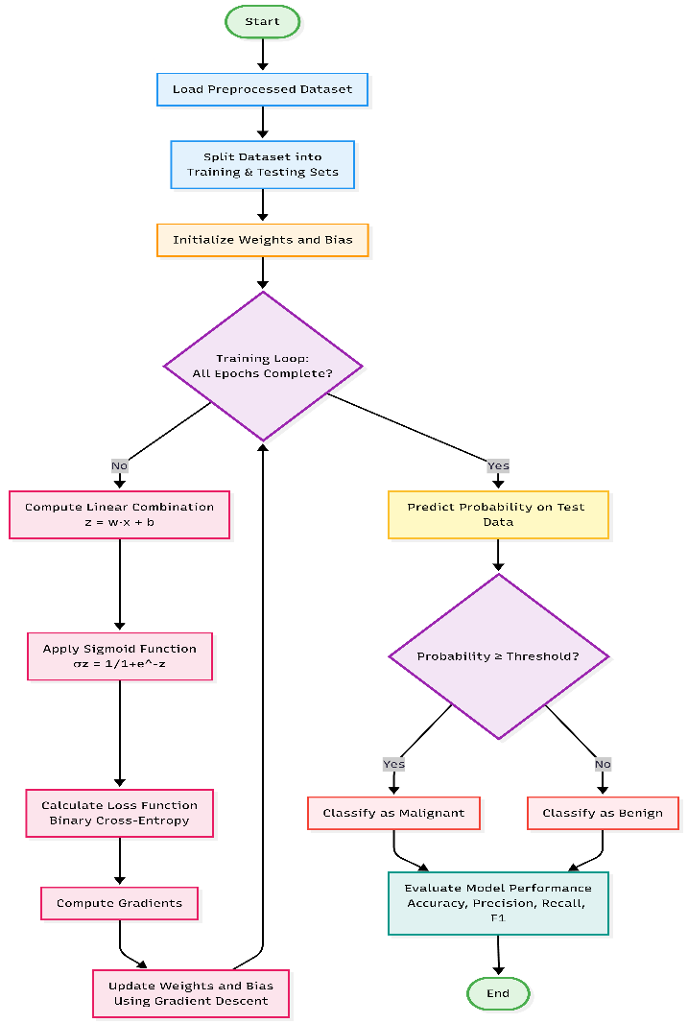
Figure 18: Logistic Regression Flow Chart.

3.4.2. Flow Chart for Decision Tree

Algorithm: Decision Tree Construction (ID3/CART)

Input: Training dataset D with features X and labels y
Output: Decision Tree T

1. START
2. Load preprocessed dataset
3. Split data into training set and testing set

4. FUNCTION BuildTree(D, features):
a. IF stopping condition met THEN
- All instances have same class label, OR
- Maximum depth reached, OR
- Minimum samples threshold reached, OR
- No more features to split
RETURN Leaf Node with majority class label
END IF

b. Initialize best_feature = NULL
c. Initialize best_gain = 0 (or best_gini = ∞)

d. FOR each feature f IN features DO:
i. FOR each possible threshold t DO:
- Split dataset D into D_left and D_right based on f ≤ t
- Calculate Information Gain:
Gain(D, f, t) = Entropy(D) - [|D_left|/|D| · Entropy(D_left)
+ |D_right|/|D| · Entropy(D_right)]
OR Calculate Gini Index:
Gini(D, f, t) = |D_left|/|D| · Gini(D_left)
+ |D_right|/|D| · Gini(D_right)
- IF Gain > best_gain (or Gini < best_gini) THEN
best_feature = f
best_threshold = t
best_gain = Gain (or best_gini = Gini)
END IF
END FOR
END FOR

e. Create decision node with best_feature and best_threshold
f. Split dataset D into D_left (f ≤ threshold) and D_right (f > threshold)
g. Left_child = BuildTree(D_left, features)
h. Right_child = BuildTree(D_right, features)
i. RETURN decision node with left and right children

5. END FUNCTION

6. Tree = BuildTree(Training_Data, All_Features)
7. RETURN Tree

Algorithm: Decision Tree Prediction
Input: Test instance x, Decision Tree T
Output: Predicted class label

1. FOR each test instance x IN X_test DO:
a. current_node = root of Tree T

b. WHILE current_node is not a leaf node DO:
i. Get feature and threshold from current_node
ii. IF x[feature] ≤ threshold THEN
current_node = left_child
ELSE
current_node = right_child
END IF
END WHILE

c. Predicted_class = class label at current_node (leaf)
d. Store prediction

2. END FOR

3. Evaluate performance:
- Calculate Accuracy, Precision, Recall, F1-Score

4. END
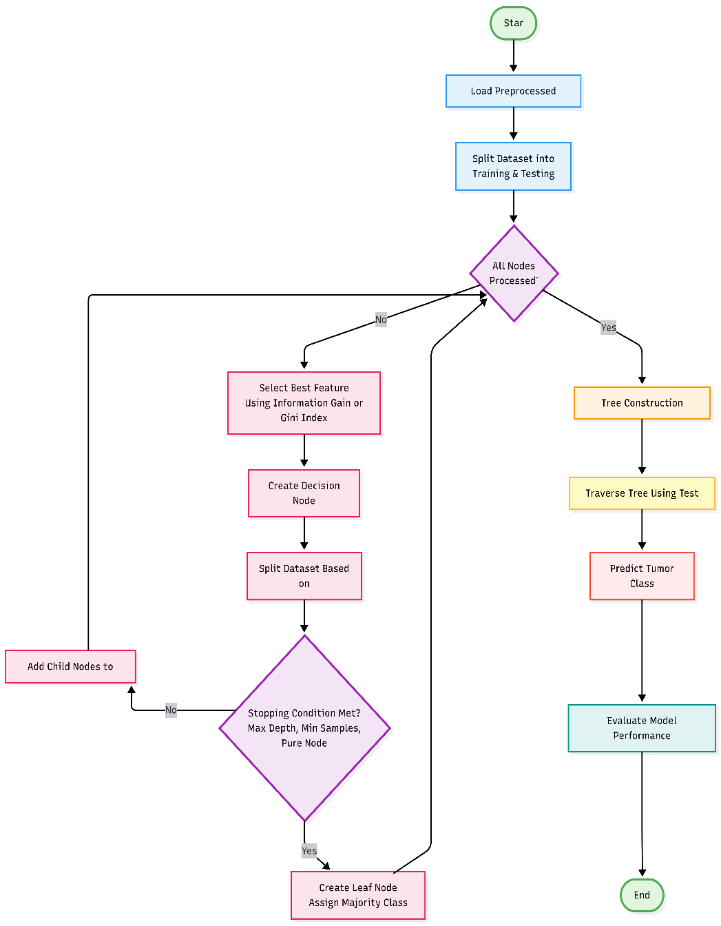
Figure 19: Decision Tree Flow Chart.

3.4.3. Flow Chart for K-Nearest Neighbours

Algorithm: Data Normalization

Input: Dataset X with numerical features
Output: Normalized dataset X_norm

1. START
2. Load preprocessed dataset

3. FOR each feature column f IN X DO:
Option A - Min-Max Normalization:
- min_val = minimum value in f
- max_val = maximum value in f
- FOR each value v IN f DO:
v_norm = (v - min_val) / (max_val - min_val)
END FOR

Option B - Z-Score Normalization:
- mean = average of values in f
- std = standard deviation of f
- FOR each value v IN f DO:
v_norm = (v - mean) / std
END FOR

4. END FOR

5. RETURN normalized dataset X_norm

Algorithm: K-Nearest Neighbors Classification

Input: Training set X_train, y_train
Test set X_test
Value of K (number of neighbors)
Output: Predicted class labels for X_test

1. START
2. Normalize features in training and test sets
3. Split dataset (already have X_train, y_train, X_test, y_test)
4. Set K value (e.g., K = 3, 5, 7, etc. - usually odd number)

5. FOR each test instance x IN X_test DO:

a. Initialize distance_list = empty list

b. FOR each training instance x_i IN X_train DO:
i. Calculate distance between x and x_i:

Euclidean Distance:
d = √(Σ(x[j] - x_i[j])²) for all features j

OR Manhattan Distance:
d = Σ|x[j] - x_i[j]| for all features j

OR Minkowski Distance:
d = (Σ|x[j] - x_i[j]|^p)^(1/p) for parameter p

ii. Store (distance d, class label y_i) in distance_list
END FOR

c. Sort distance_list in ascending order by distance

d. Select K nearest neighbors (first K entries in sorted list)

e. Extract class labels of K nearest neighbors

f. Apply majority voting:
i. Count occurrences of each class label
ii. class_counts = {class_0: count_0, class_1: count_1, ...}
iii. predicted_class = class with maximum count
iv. IF tie occurs THEN
- Use K-1 neighbors, OR
- Choose class of nearest neighbor, OR
- Random selection
END IF

g. Assign predicted_class to test instance x

6. END FOR

7. Evaluate model performance:
- Calculate Accuracy = (Correct Predictions) / (Total Predictions)
- Calculate Precision = TP / (TP + FP)
- Calculate Recall = TP / (TP + FN)
- Calculate F1-Score = 2 · (Precision · Recall) / (Precision + Recall)
- Create Confusion Matrix

8. END
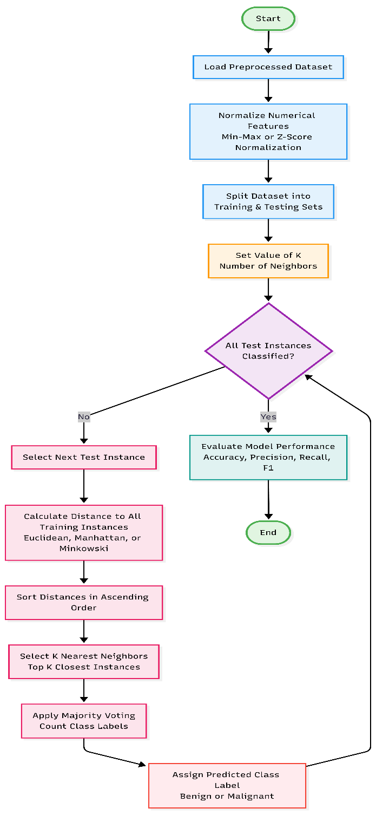
Figure 20: KNN Flow Chart.

3.5. Development Process

3.5.1. Data Acquisition and Loading
Objective: To import the dataset correctly and ensure the structural integrity of the dataset prior to any analysis.
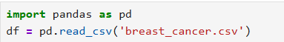
Figure 21: Import and Load Dataset.

3.5.2. Structural Inspection of the Dataset
This step verifies that the dataset matches the expected dimensions and has been loaded correctly.
Dataset Shape
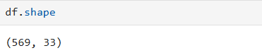
Figure 22: Dataset Shape.
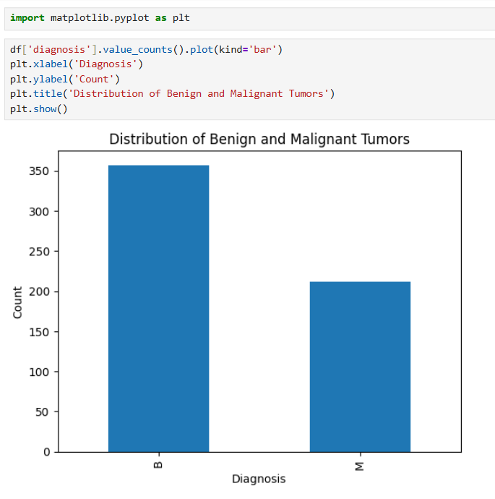
Figure 23: Distribution of Benign and Malignant Tumours.
Here, 569 rows represent individual patient cases, and 33 columns represent identifiers, diagnostic labels, and feature measurements which confirms successful data ingestion and provides baseline dimensional awareness.

Column Name Inspection
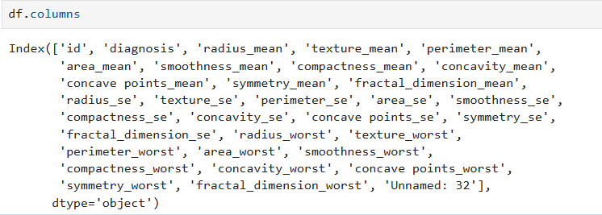
Figure 24: Column Name Inspection.
This step helps:
- Determine the target variable (diagnosis).
- Find columns that are not informative.
- Recognize the mean, standard error, and worst feature naming conventions.

Data Type Verification
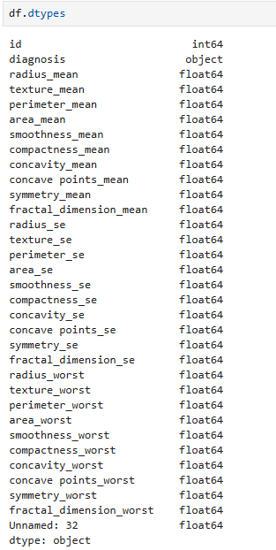
Figure 25: Datatype Verification.
This confirms that all predictive features are of numerical type and makes sure machine learning algorithms can work without issues. Apart from that, if there are any type casting mistakes, it catches them early.

3.5.3. Data Quality Assessment
Formal quality checks are required even in cases where datasets are known to be clean.
Missing Value Analysis

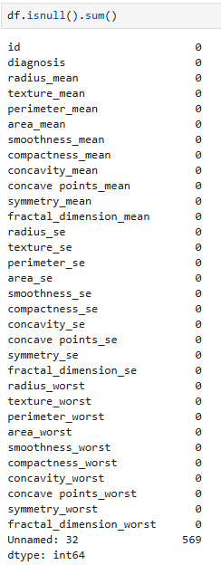
Figure 26: Missing Value Analysis.
Interpretation:
- There are no missing values in any of the core attributes.
- There are 569 missing values in Column Unnamed: 32, which indicates that it contains no useful information.
- This column needs to be eliminated because it is an artifact from the CSV export.
Removal of Completely Null Column
Figure 27: Removal of Null Column.
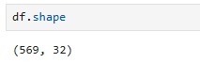
Figure 28: Verification of Removal.
Eliminating unnecessary columns enhances:
- Efficiency of computation
- Interpretability of the model
- Clarity of analysis
Duplicate Record Check
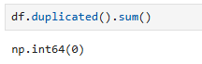
Figure 29: Duplicate Record Check.
This makes sure there are no duplicate patient records which stops biased model training and the dataset is verified to be unique if the output is 0.

3.5.4. Statistical Data Understanding
Descriptive Statistics
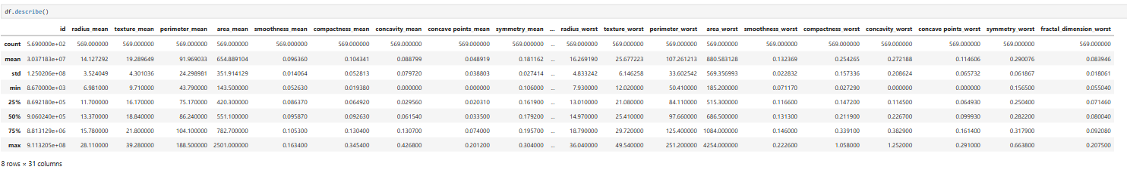
Figure 30: Descriptive Statistics check.
This stage offers:
- Min/max, mean, and standard deviation
- Detecting range
- Early detection of anomalies
It confirms that:
- There are various scales of features.
- Later, feature scaling will be necessary.
Target Variable Distribution
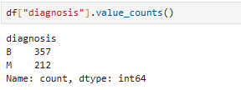
Figure 31: Target Value Distribution.
This shows the distribution of classes (Benign vs. Malignant) and finds a moderate disparity in class. It justifies the careful choice of metrics (precision & recall)

3.5.5. Outlier Detection
Outliers should not be assumed to be non-existent even in medical datasets.
Boxplot Visualization
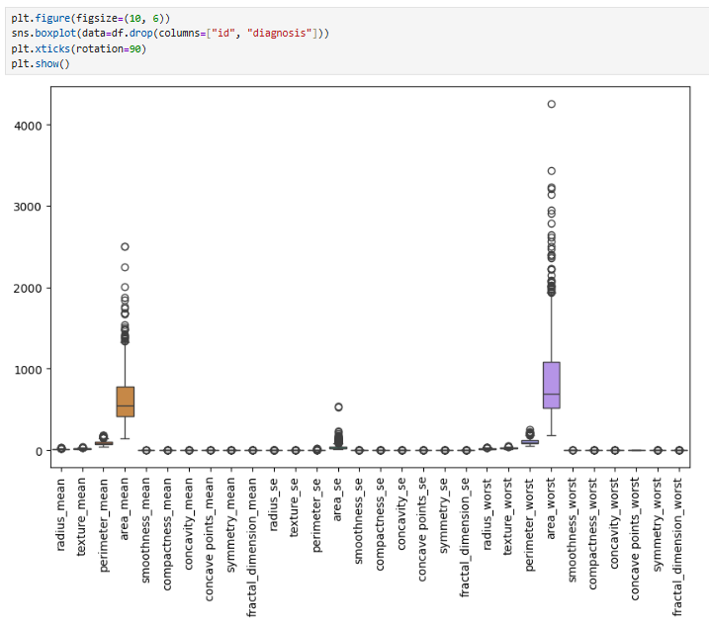
Figure 32: Boxplot Visualization of Outlier.
It confirms existence of extreme values. Outliers are typical pathological cases in medical data. Therefore, outliers are retained, not eliminated.

3.5.6. Feature Preparation
Encoding Target Variable
Figure 33: Encoding Target Variable.
This transforms categorical data to numeric which allows supervised binary classification.
Feature-Target Separation
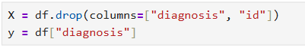
Figure 34: Feature/Target Separation.
Here, id is removed as it has no predictive value and prevents model leakage and bias.
Feature Scaling
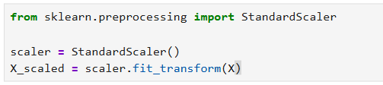
Figure 35: Feature Scaling.
It is critical to distance-based algorithm (KNN) and makes fair feature contribution which helps to enhances convergence of algorithm.

3.5.7. Data Partitioning
Figure 36: Data Partitioning.
Here, 80% data are allocated for training whereas 20% data are allocated for testing which prevents overfitting and ensures generalization and set random_state to ensure same train and test data splits on every time the code run.

3.5.8. Machine Learning Model Implementation

3.6. Achieved Results

4. Conclusion

4.1. Analysis of the work done
This project proposal has aimed at discussing how machine learning techniques can be used to early diagnose breast cancer under supervision. It started by thoroughly researching the concept of Artificial Intelligence and Machine Learning before developing a thorough grasp of the supervised learning concept and its applicability in the healthcare field when solving binary classification problems.
The problem domain was thoroughly analyzed and it was possible to comprehend the importance of diagnosing breast cancer in its early stages and the inabilities of the conventional diagnostic tools. Much background research was conducted in going through the already available studies and research papers that used machine learning algorithms including Logistic Regression, Decision Tree and K-Nearest Neighbours (KNN) to medical data. This study brought a lot of knowledge on the effectiveness, strengths and weaknesses of all the algorithms.
The project also suggested an organized solution that comprises of data preprocessing, feature normalization, model training, testing and performance evaluation. It was designed with clear pseudocode and flowcharts to demonstrate how the overall system and single algorithms would work. By adopting this type of analysis, the proposal shows a great level of knowledge in terms of both theoretical and practical considerations of machine learning-based diagnostic systems.
Overall, the research conducted in this proposal provides a strong basis on how to employ a dependable and interpretable model of breast cancer prediction by utilizing supervised learning.

4.2. How the solution addresses real world problems
The solution proposed will directly focus on the real-life issues related to breast cancer diagnosis. Early and proper diagnosis of breast cancer is very important in enhancing patient survival and minimization of costs of health care. Nevertheless, the conventional method of diagnosis is usually very time consuming, costly and relies on expert analysis and can result in delays and discrepancies in diagnosis.
The proposed system can be used to classify the breast tumours as malignant or benign at a high level of accuracy by applying machine learning algorithms to facilitate a data-driven approach with little human involvement. Predictions using interpretable models like the Logistic Regression and Decision Trees provide a sense of transparency, and it is imperative in winning the confidence of clinicians. Besides, KNN increases the reliability of the diagnosis as it finds similarities between patient cases.
It can be used as a clinical decision-support tool and can help healthcare practitioners to make more and faster diagnostic decisions. It has a specific advantage in the resource-scarcity or distance healthcare environments where a patient might lack access to specialists and modern diagnostic tools. The proposed system will make healthcare delivery more efficient and fairer by minimizing the human error and time devoted to the diagnosis.

4.3. Future Work
Although this proposal presents an elaborate machine learning-based solution in the diagnosis of breast cancer, some areas can be improved in the future. The second step of the project will encompass the entire application of the suggested models with the help of programming languages like Python and machine learning libraries. The dataset will be trained and tested on the model whereby performance will be evaluated and compared in detail.
The need to experiment with more sophisticated algorithms like Support Vector Machines, Random Forests or deep learning models could also be included in future work to ensure prediction accuracy further. To optimize the model performance and minimise the computational complexity, the feature selection and dimensionality reduction methods can be used. Moreover, it would make the model more practical to be incorporated into a real-time clinical system or electronic health record platform.
To sum up, the present proposal is a foundation to build an intelligent breast cancer diagnosis system, that helps to show the potential of artificial intelligence in the field of healthcare. The proposed solution can play an important role in cancer detection at an early stage and a better patient outcome with further development and validation.

References
Arslan Khalid, A. M. A. A. B. F. A. F. A. H. A. G. S. C., 2023. Breast Cancer Detection and Prevention Using Machine Learning.. Diagnostics 2023, Volume 13, p. 21.
Aryan Sai Boddu, A. J., 2025. ScienceDirect. [Online]
Available at: https://www.sciencedirect.com/science/article/abs/pii/S0040816625002095
[Accessed 13 December 2025].
Bergmann, D., 2025. IBM. [Online]
Available at: https://www.ibm.com/think/topics/machine-learning
[Accessed 13 December 2025].
Google Cloud, 2025. Google Cloud. [Online]
Available at: https://cloud.google.com/learn/what-is-artificial-intelligence
[Accessed 13 December 2025].
Kavlakoglu, E., 2025. IBM. [Online]
Available at: https://www.ibm.com/think/topics/decision-trees
[Accessed 15 December 2025].
Kavlakoglu, E., 2025. IBM. [Online]
Available at: https://www.ibm.com/think/topics/knn
[Accessed 15 December 2025].
Lee, F., 2025. IBM. [Online]
Available at: https://www.ibm.com/think/topics/logistic-regression
[Accessed 15 December 2025].
Lucidchart, 2025. Lucidchart. [Online]
Available at: https://www.lucidchart.com/pages/what-is-a-flowchart-tutorial
[Accessed 14 December 2025].
Mohammed Amine Naji, S. E. F. K. A. E. H. B. R. A. A. O. D., 2021. Science Direct. [Online]
Available at: https://www.sciencedirect.com/science/article/pii/S1877050921014629
[Accessed 13 December 2025].
Mubarak Taiwo Mustapha, D. U. O. I. O. B. U., 2022. Breast Cancer Screening Based on Supervised Learning and. Diagnostics, Volume 12, p. 17.
National Cancer Institute, 2025. National Cancer Institute. [Online]
Available at: https://www.cancer.gov/types/breast/causes-risk-factors/benign-breast-lumps
[Accessed 13 December 2025].
R. Fang, D. L. T. M. D. D. X. Z., 2025. IEEE Xplore. [Online]
Available at: https://ieeexplore.ieee.org/document/278764
[Accessed 13 December 2025].
Seeta Devi, R. K. G. J. A. P. D. D., 2024. Prediction and Diagnosis of Breast Cancer Using Machine and. Machine and Deep Leaning Models for Prediction of Breast Cancer, Volume 25(3), p. 1085.
Stanford University, 2025. Stanford University Human - Centered Artificial Intelligence.. [Online]
Available at: https://hai.stanford.edu/ai-index/2025-ai-index-report
[Accessed 13 December 2025].
Taminul Islam, M. A. S. M. S. T. M. H. H. S. A. Y. A. B. J. G. F. H.-A. N. M. B., 2024. Predictive modeling for breast. Scientific Reports, Volume 14, p. 17.
WHO, 2025. WHO. [Online]
Available at: https://www.who.int/news-room/fact-sheets/detail/breast-cancer
[Accessed 13 December 2025].
Yoo-Shin Park, P. T. K. P. B.-C. M., 2025. Health Informatics Journal. [Online]
Available at: https://healthinformaticsjournal.com/index.php/IJMI/article/view/430
[Accessed 13 December 2025].

